W03 Project: Rafting Site – Planning Document

Eleanor Foster

1. Logo image

1. Write out the four (4) color labels with the color codes you selected:
   * A blue orange and white stripes

     AI-generated content may be incorrect.primary-color _#3EB3F2__
   * secondary-color __#15A3EF_____
   * accent1-color _#F9F7F3___
   * accent2-color _#F3742F__
2. Write out the two (2) font labels and the names of the fonts you selected:
   * heading-font _Caveat
   * text-font _____Inter___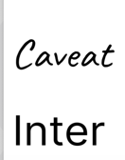
3. Provide the URL link to your color palette:

https://coolors.co/3eb3f2-15a3ef-f9f7f3-f28d2e